SQL Server Integration Services

# Module 04 – LAB 03 – Exercise 01: CheckPoints

1. Create new integration services project.
2. Set up a connection manager for the database. In the bottom center pane under Connection Manger, right-click select New Ole-DB Connection.  
   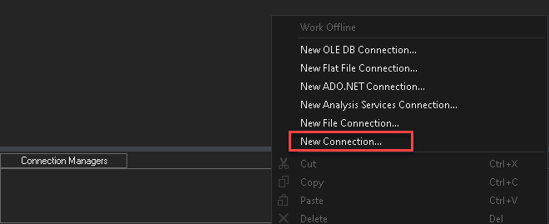
3. In Configure OLE DB Connect Manager, click New.  
   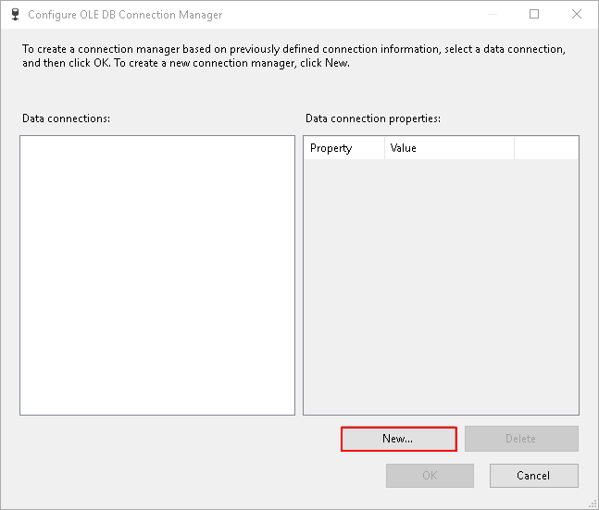
4. Setup connection to SQL Server pointing to the AdventureWorks database.

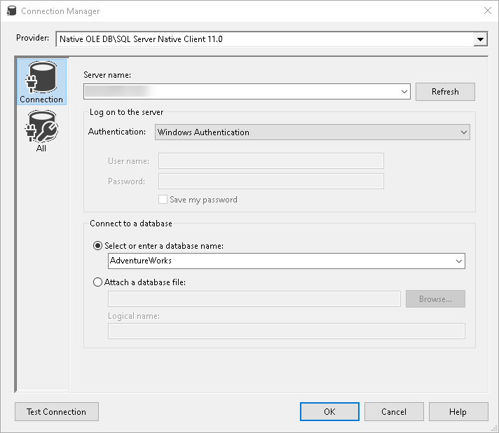

1. Create a new Project Parameter, “CheckpointPath”. Set it to String value with default value C:\Temp\ (confirm the path exists, if not create it).



1. Set Package Checkpoint properties – Leave CheckpointFileName as blank.

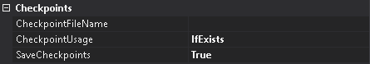

1. The CheckpointFileName should be dynamic, therefore we must use expressions to set the value.

Expression: @[$Project::CheckpointPath] +@[System::PackageName] + "_SSIS_Checkpoint.xml"

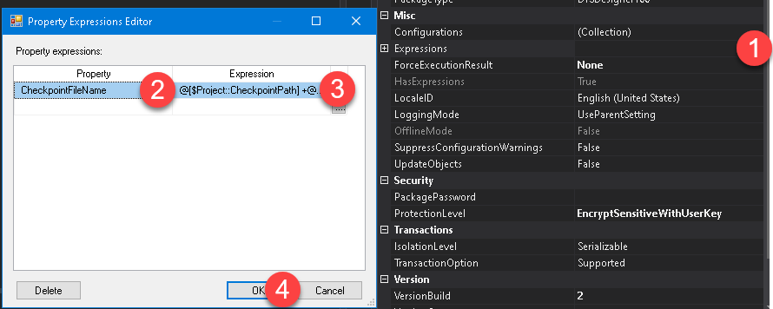

1. Create three “Execute SQL Task” and respective SQL code and link it to connection created in step #1. Set the property “FailPackageOnFailure” to true for each task.

|  |  |
| --- | --- |
| Task Name | SQL Code |
| Get Server Name | SELECT @@ServerName |
| Get Server Version | SELECT @@Versions |
| Get Database Count | SELECT COUNT(*) AS DBCount FROM sys.databases |

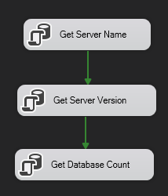   
  
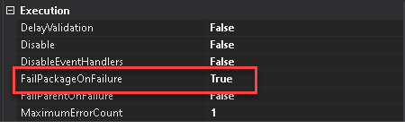

1. Execute the task, it should fail at “Get Server Version.”

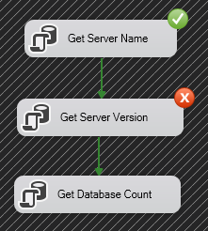

1. Review the checkpoint file that got created in C:\Temp\ (reformatted for lab).



1. The package failed because “Get Server Version” SQL code is incorrect. Update the code to “SELECT @@Version” and rerun. Notice this time, it skips the first SQL Task due to check point.

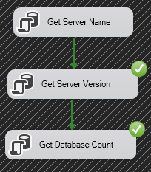

1. Review the C:\Temp\ notice the checkpoint should have been deleted at the end of execution.
2. Re-run the package. This time all three steps run, because the check point file was deleted after previous execution.

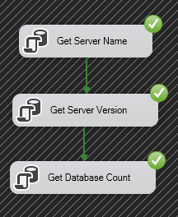

# Module 04 – LAB 03 – Exercise 02: Transactions

*Note: Instructions in this exercise are not as detailed intentionally. Review previous labs if unsure how to complete some steps.*

1. Create new integration services project.
2. Set up a connection manager for the database. In the bottom center pane under Connection Manger, right-click select New Ole-DB Connection.  
   
3. In Configure OLE DB Connect Manager, click New.  
   
4. Setup connection to SQL Server pointing to the AdventureWorks database.



1. Create a new table in SQL Server.

|  |
| --- |
| CREATE TABLE dbo.TxSequences (SeqNum INT, CallLoc VARCHAR(255), DateSaved DATETIME) |

1. Create a new package variable.

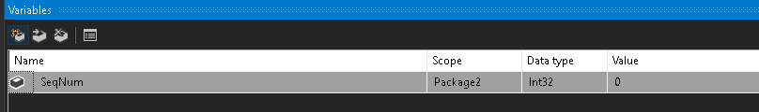

1. Setup a package layout as below.

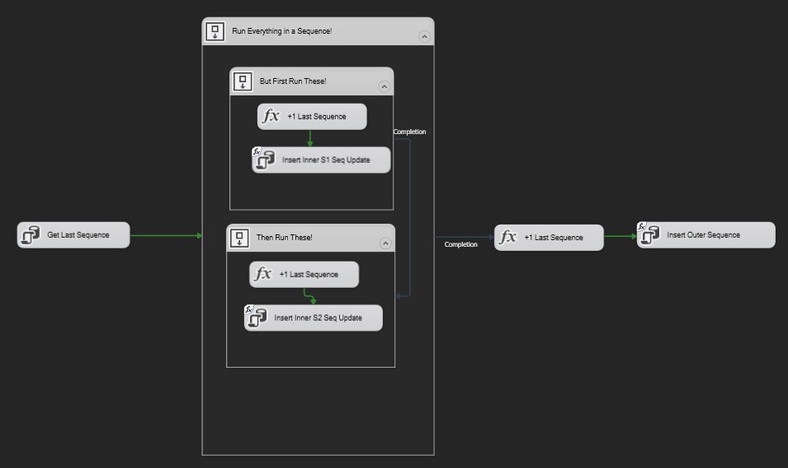

1. Update “Get Last Sequence”.

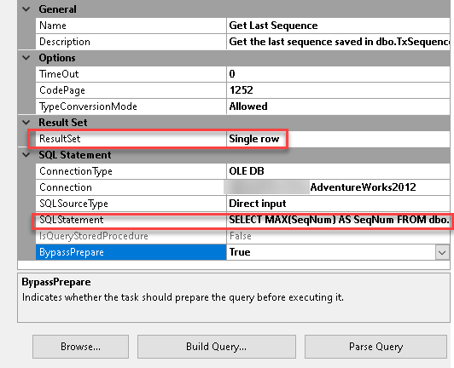

|  |
| --- |
| SELECT MAX(SeqNum) AS SeqNum FROM dbo.TxSequences |

1. Output results to variable created in step #6.

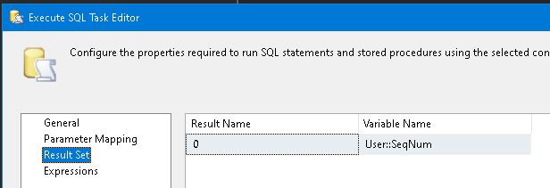

1. Update each Expression Tasks (three in total) to following expression.

|  |
| --- |
| @[User::SeqNum] = @[User::SeqNum]+1 |

1. Update each Execute SQL Task (excluding Get Last Sequence) to use expression for SQL string. Use the following expression.

|  |
| --- |
| "INSERT INTO dbo.TxSequences VALUES (" + (DT_WSTR,5) @[User::SeqNum] + ", 'Inner S1', GETDATE())" |

1. Execute the package after all the updates are completed. The default execution should run without problem.

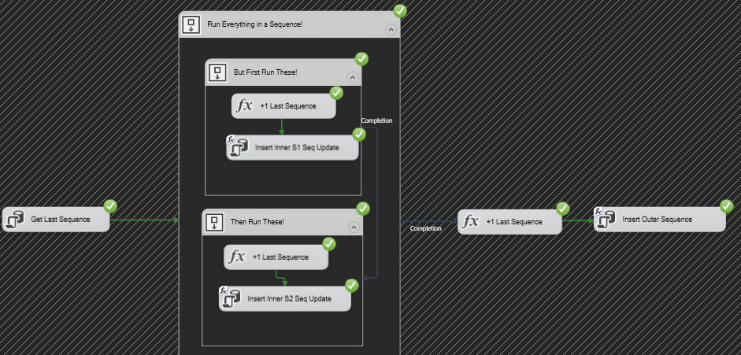

1. Verify the results in the SQL Server with the following code.

|  |
| --- |
| SELECT *  FROM dbo.TxSequences  DELETE  FROM dbo.TxSequences |

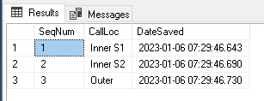

1. Next modify the “Insert Outer Sequence” SQL string expression to the following value.

|  |
| --- |
| "INSERT INTO dbo.TxSequences VALUES (1," + (DT_WSTR,5) @[User::SeqNum] + ", 'Outer', GETDATE())" |

1. Execute the package and review SQL data as in step #13. We should get only two rows. Because by default SSIS each container/task is their own transactions.

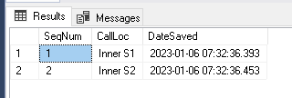

1. Next change the package property **TransactionOption** to **Required** and rerun the package. Review SQL data as in step #13. This time we get no rows because the entire package is built as a single transaction.
2. Next change the package property **TransactionOption** back to **Supported** but change the outer sequence “Run Everything in a Sequence!” **TransactionOption** to **Required**. Rerun the package and review the results. We get results like #15.

.